**Experiment No. - 1.4**

**Student Name: Deepak Saini UID: 20BCS4066**

**Branch: 20BCC1 Section/Group: A**

**Semester:**  **5th Date of Performance: 24/08/2022**

**Subject Name: ADVANCED PROGRAMMING LAB**

**Subject Code: 20CSP-334**

1. **Aim/Overview of the practical:**

Write a program to maintain a elementary database of employees using files.

1. **Task to be done:**

Write a program to maintain a elementary database of employees using files.

1. **Steps for practical**:
2. Include the header files.
3. Open a file in write mode.
4. Write inputted data into the file.
5. Close the opened file.
6. Open a file in read mode.
7. write the data at the screen.
8. Again read the data from the file and display it.
9. Close the opened file.

**4 . Code:**

#include <fstream>

#include <iostream>

using namespace std;

int main () {

char data[100];

// open a file in write mode.

ofstream outfile;

outfile.open("Employee_database.dat");

cout << "Writing to the file" << endl;

cout << "Enter your name: ";

cin.getline(data, 100);

// write inputted data into the file.

outfile << data << endl;

cout << "Writing to the file" << endl;

cout << "Enter your Employee ID: ";

cin.getline(data, 100);

// write inputted data into the file.

outfile << data << endl;

cout << "Enter your age: ";

cin >> data;

cin.ignore();

outfile << data << endl;

cout << "Enter your Salary: ";

cin >> data;

cin.ignore();

outfile << data << endl;

cout << "Enter your designation: ";

cin.getline(data, 100);

cin.ignore();

// again write inputted data into the file.

outfile << data << endl;

// close the opened file.

outfile.close();

// open a file in read mode.

ifstream infile;

infile.open("Employee_database.dat");

cout << "Reading from the file" << endl;

infile >> data;

// write the data at the screen.

cout << data << endl;

// again read the data from the file and display it.

infile >> data;

cout << data << endl;

// again read the data from the file and display it.

infile >> data;

cout << data << endl;

// again read the data from the file and display it.

infile >> data;

cout << data << endl;

// again read the data from the file and display it.

infile >> data;

cout << data << endl;

// close the opened file.

infile.close();

return 0;

}

**5.** **Output:**

**a)** 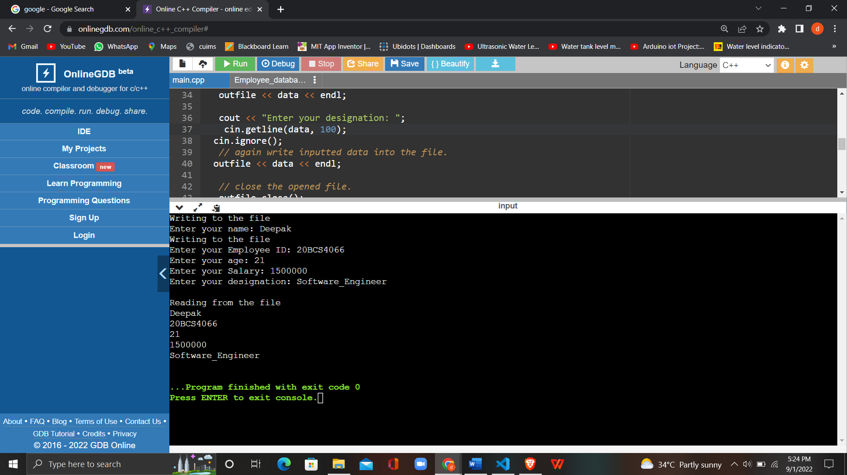

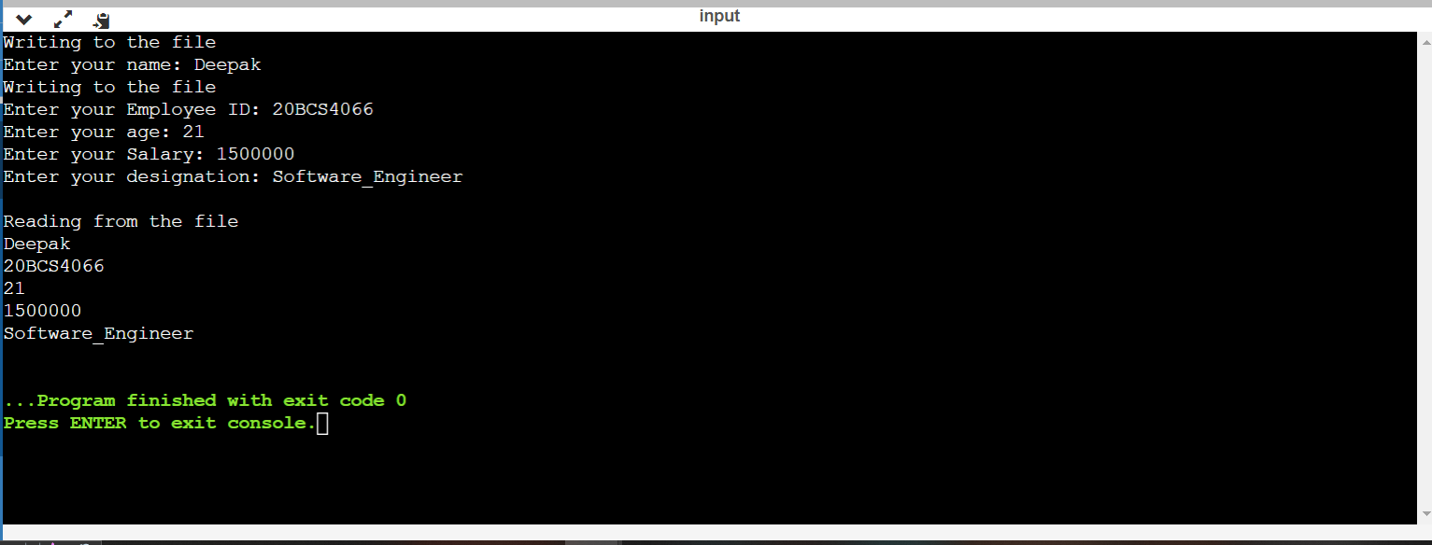

b)

